**Integration and Configuration**

In Assignment 3, we are given three tables to use. These tables are for Student, Instructor, and Admin. The tables contain the same information we were planning to include into our tables. So, it would be beneficial to integrate these precreated tables into our project.

Pictures of tables.

The assignment also contains some code that we could integrate. For example, creating a table:

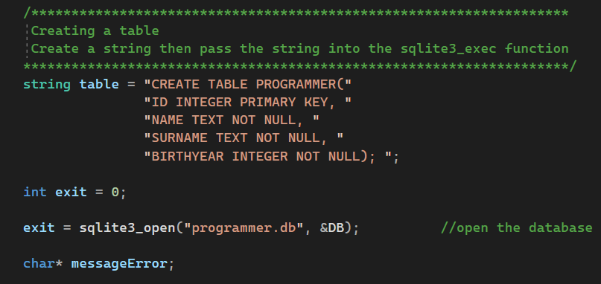

Last semester, I worked with objects and classes in my object oriented programming class. There are many old labs and projects I have done that contain classes that could be integrated into the LeopardWeb Project.

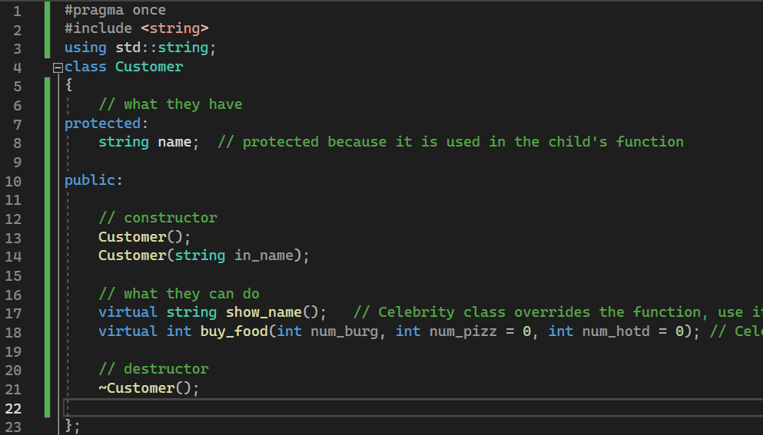

Screenshot of Lab from Last Semester

Doing this will be very useful because my memory of how to set up and use these classes in complex ways is a little foggy.